Guía3. Informe final Proyecto APT
Asignatura Capstone

1. Informe final Proyecto APT
El objetivo de este informe es que describas los aspectos más relevantes de tu Proyecto APT. Es importante que fundamentes las decisiones que tuviste que tomar a lo largo del proceso.

A continuación, encontrarás distintos campos que deberás completar con la información solicitada, los que dan cuenta del resumen de tu proyecto APT y sus principales resultados.

Nombre del proyecto | Enter the name of your APT Project.  Focus Power Fit CRM: Web-Based System for the Comprehensive Management of a Personal Training Gym
Área (s) de desempeño(s) | List the professional areas from your study program addressed by your APT Project.  Software development; IT project management; software quality assurance; databases; and information security.
Competencias | List the competencies from your study program addressed by your APT Project.  Develop and integrate software solutions based on requirements; design and manage relational data models; apply testing and quality assurance techniques; manage IT projects using agile methodologies; and incorporate information security best practices. These competencies are demonstrated through the CRM development, the 13-table data model, Scrum management, testing, and access controls.

Contenidos del informe final
1. Relevancia del proyecto APT | - Describe the problem your project sought to solve and its relevance to your profession. The following questions may help you complete this section:  - Why is this topic relevant to the professional field of your degree?  - Where is the situation you are addressing located? (e.g., country, region, municipality, or institution). What are the main characteristics of that location?  - Who is affected or impacted by the situation you addressed? (e.g., age group, users of a service, etc.).  - What value did your APT Project contribute (real or simulated) to the professional and/or social context in which it took place?  Answer:  Focus Power Fit is a personal training gym with branches in La Reina and Peñalolén, Santiago, Chile. Before the project, the management of clients, plans, schedules, attendance, contracts, and payments depended on spreadsheets and in-person or messaging-based coordination. This made it difficult to track sessions, manage available slots, and access information promptly. The situation affected the owner, staff, and clients at both branches. The project adds value by centralizing these processes in a web-based CRM with an administration panel, client portal, reminders, and a frequently asked questions assistant. For Computer Engineering, it represents a real-world application of requirements analysis, software development, databases, quality assurance, and security. Thus, the project seeks not only to digitize administrative tasks but also to improve information continuity between branches, reduce reliance on manual records, and support the owner’s decision-making through centralized, up-to-date information.
2. Objetivos | - General and specific objectives.  What is the general objective of your APT Project? What are its specific objectives?  Answer:  General objective: Develop a web-based management platform with a CRM approach for Focus Power Fit, enabling the owner to centralize gym administration and giving clients controlled access to their information, while incorporating automated reminders and a guidance chatbot.  Specific objectives:  (1) Analyze and document requirements and business rules; (2) design a modular, maintainable solution, including architecture, data model, and interfaces; (3) implement management of clients, trainers, plans, schedules, attendance, contracts, and administrative records; (4) incorporate authentication and role-based access control; (5) automate email reminders; (6) integrate FitBot for frequently asked questions; and (7) integrate and validate the components through testing. The objectives related to analysis, design, development, and integration were achieved in the testing environment. However, final validation with real users and definitive acceptance of some features remained pending for Phase 3. Therefore, a distinction is made between implemented components and those that still require adjustments or validation.
3. Metodología | - Methodology used and its suitability for achieving the objectives.  Which methodology did you use to develop your APT Project? Describe the phases and procedures you followed to carry out your project.  Explain why this methodology was appropriate for achieving the stated objectives.  Answer:  Scrum was used, organized into six sprints (Sprint 0 through Sprint 5) over 18 weeks. Martina Vergara served as Product Owner; Katherine Hermosilla as Scrum Master; and all three team members participated as developers. The team produced a Product Backlog, Sprint Backlogs, functional increments, reviews, and retrospectives, supported by a Gantt chart and GitHub. The sprints covered definition and design; authentication and client management; trainers, plans, schedules, and attendance; contracts and the client portal; reminders, FitBot, and integration; and finally testing, corrections, and documentation. Scrum was appropriate because it enabled the team to incorporate client feedback, prioritize real needs, and validate incremental deliveries while maintaining traceability.
4. Desarrollo | - Description of the APT Project stages or activities.  What stages or activities did you carry out in your APT Project?  - Challenges and enabling factors during APT Project development.  What elements or aspects facilitated or supported the development of your APT Project?  What challenges did you face while developing your APT Project?  - Adjustments made.  How did you address the challenges in order to meet the objectives? Did you have to make any adjustments? Which ones?  Answer:  The project was developed in five stages. The first involved gathering and analyzing requirements, identifying the gym’s needs and business rules. The second involved designing the solution, including its architecture, interfaces, and relational data model. The third consisted of implementing the frontend with Next.js 16 and React 19, developing the REST API with Node.js and Express 5, and persisting data with MySQL 8.0 and Sequelize. The fourth stage included integrating email services and FitBot through n8n and Ollama, and preparing the deployment environment with Docker and Caddy. Finally, testing, corrections, and documentation were completed. As a result, 12 administration modules and a client portal were integrated.  Enabling factors included team collaboration, version control tools, automated testing, and the business rules provided by the gym. Challenges included data migration and cleansing, differences between initially planned and ultimately adopted technologies, security controls, and the quality of FitBot responses. During development, technological adjustments were made to align the tools with the team’s implementation decisions. MySQL was used instead of PostgreSQL, and Tailwind instead of Bootstrap. Postman and route and permission documentation were used to review the API endpoints instead of Swagger. A six-hour cancellation rule, branch management, and encrypted backups were also incorporated. One challenge was obtaining consistent FitBot responses. To address this, different queries were tested and its behavior was reviewed in the integration environment. The results identified response limitations and indicated that the evaluated version required further improvements before final approval. At the November review, the system had been built, integrated, and tested in an environment prepared for production, but it had not been deployed to a contracted server. RF-20 remained partially implemented because frequently asked questions were edited in n8n rather than from the administration panel. Validation with real clients and the owner’s final approval of the current FitBot version were also pending.
5. Evidencias | - Attach evidence demonstrating the development of the APT Project and its final results.  What evidence could help others visualize and understand the different stages of your APT Project and its final outcome?  Answer:  The evidence for the Focus Power Fit CRM project demonstrates the different stages of planning, design, development, integration, and quality assurance. It is documented in the APT Project Final Report – Phase 2, its appendices, and the GitHub repository.  The main evidence includes:  - Planning and methodology: Gantt chart, Product Backlog, Sprint Backlogs, and progress tracking records showing team organization and completion of activities.  - Solution design: three-layer architecture, a 13-table relational data model, and 15 mockups of the system’s main interfaces.  - Development and implementation: frontend and backend source code, administration modules, client portal, FitBot integration, and email reminders.  - Version control: GitHub repository (https://github.com/katherinehermosilla00/focus-power-fit), with working branches and pull requests showing changes made and team member participation.  - Quality assurance: 126 passed automated backend tests and a QA campaign with 127 of 147 cases passed, complemented by testing with Postman, Playwright, Chrome DevTools, and OWASP ZAP.  - Security and continuity: documentation of access controls, security reviews, and encrypted backup restoration tests.  - Documentation: user manual, technical documentation, functional and non-functional requirements records, defect log, and quality and security documentation.  The QA campaign identified five defects. Four were corrected and retested, while the fifth concerned limitations in FitBot responses, with 35 adequate responses out of 52 conversations evaluated. The Next.js error screenshot included in this document is retained as evidence of an issue observed during development; by itself, it does not demonstrate that the issue was fixed.  The evidence is located in the GitHub repository (https://github.com/katherinehermosilla00/focus-power-fit), the project documentation folder, and the Phase 2 report appendices. It supports the work performed and the results achieved. However, the tests performed do not replace final client acceptance or validation with real users, which remain pending activities for Phase 3.  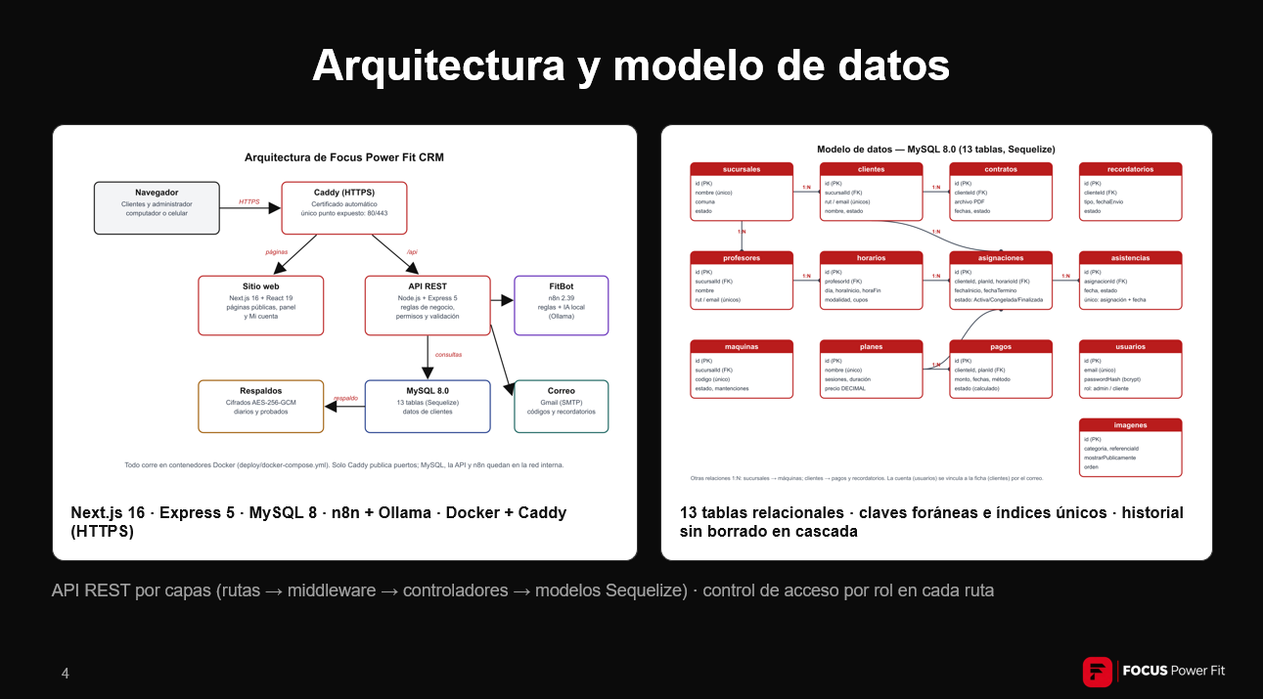  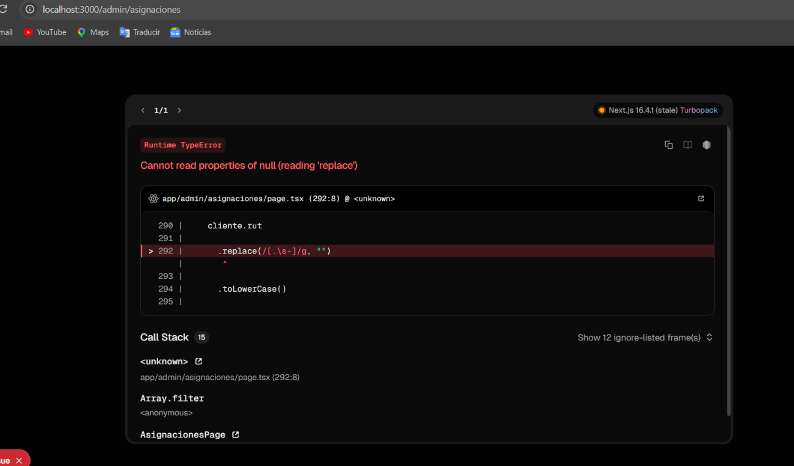
6. Intereses y proyecciones profesionales | - Reflection on the contribution of the APT Project to the development of professional interests.  How did your APT Project help you gain a better understanding of your professional interests? After completing your APT Project, are your professional interests still the same as those you identified at the beginning of the course?  - Career aspirations arising from the APT Project.  Which professional interests would you like to explore or develop further?  How do you envision your professional career after completing your APT Project?  Answer:  Katherine Hermosilla: Focus Power Fit strengthened my interest in IT project management and software development by allowing me to coordinate the team’s work, integrate features, and apply quality practices. I see myself contributing to the development of technological solutions and the management of IT projects.  Martina Vergara: The project strengthened my interest in IT project management through requirements gathering, work prioritization, and communication with the client. I would like to deepen my knowledge of functional analysis, team coordination, and technology product management.  Javier Vargas: The project relates to my interest in data science because the CRM collects and organizes information that can be analyzed to identify patterns and support decision-making. I would like to further explore data analysis and the development of solutions that turn operational records into useful information.

